Learning Scenarios Portal

User Guide

Table of Contents
Introduction 2
About Learning Scenario Portal 2
Access to the Learning Scenario portal 3
Adding New Learning Scenarios 7
Why add a Learning Scenario in the repository? 7
Learning Scenario Template 8

Introduction

About Learning Scenario Portal
A "Learning Scenarios Portal" is a digital platform or repository where educators, trainers, and instructional designers can access, share, and promote specific learning scenarios.

Here's a breakdown of the concept:

Learning Scenario:
A learning scenario is a detailed plan or script for a learning activity or sequence of actions. It typically includes:

- Objective: What learners should know or be able to do by the end of the scenario.
- Content: The information, knowledge, or skills to be taught.
- Activities: The tasks, exercises, or interactions learners will engage in.
- Resources: Any materials, tools, or technologies required.
- Assessment: How learners' understanding or performance will be evaluated.

Portal:
A portal is a web-based platform that provides users access to various resources and services, often from multiple sources, in a unified way. In the context of a Learning Scenarios Portal:

- Access: Users can browse and search for learning scenarios relevant to their needs.
- Share: Educators can upload and share their learning scenarios with others.
- Promote: Highlight or feature specific scenarios for broader visibility.
- Collaborate: Users can comment on, rate, or modify shared scenarios, fostering a collaborative community.

Benefits of a Learning Scenarios Portal:
- Resource Efficiency: Educators can reuse and adapt existing scenarios rather than creating new ones from scratch.
- Quality: Access to peer-reviewed or highly-rated scenarios ensures high-quality learning experiences.
- Diversity: Scenarios from different subjects, cultures, or pedagogical approaches can offer various learning experiences.
- Community: A platform for educators to collaborate, share feedback, and improve their instructional methods.

A Learning Scenarios Portal is a valuable tool for educators, providing a centralized location to access and share structured plans for effective teaching and learning. The Up2DigiSchool Learning Scenarios Repository provides a robust environment where every educator can upload a learning scenario based on a ready template (see Section Learning Scenario Template).

Access to the Learning Scenario portal
Learning Scenarios are freely available for everyone. But To upload a Learning Scenario, you need to have a user account as a teacher. To create an account as a teacher, you can follow the instructions given in Up2DigiSchool Learning Platform Guide.

1. Accessing the Portal

Login: Ensure you are logged in before accessing the portal's features. Click on (Log in) and enter your credentials.

The following figure shows the fields mentioned before:

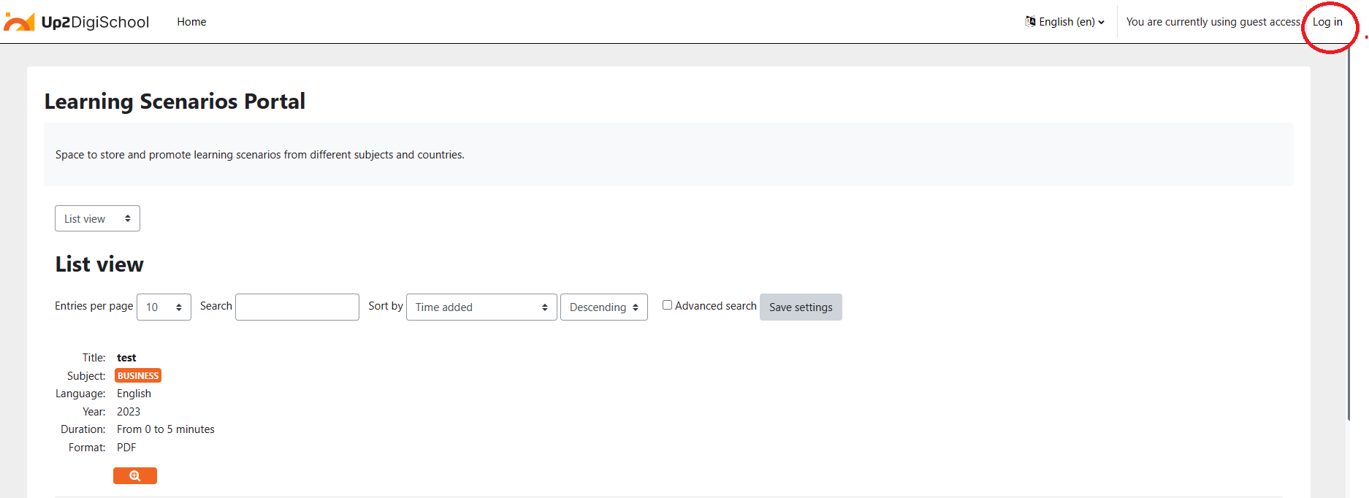
Figure 1: Log in to the Learning Scenario Repository Portal
2. Navigating the Portal:

- Skip to main Content: Click this to jump directly to the main content area.
- Home: Use this link to return to the platform's homepage anytime.

The following figure shows the fields mentioned before:

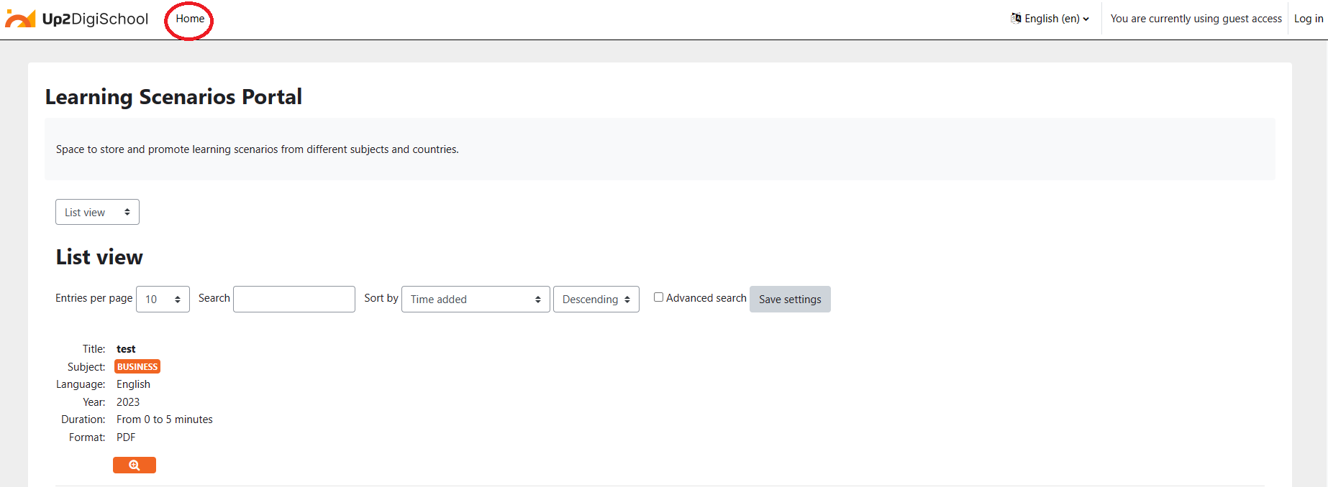
Figure 2: Homepage Button
3. Browsing Learning Scenarios:

- Browsing: Third-level navigation: This section provides different views for browsing.
  - List view: List view displays multiple learning scenarios in a list format.
  - Single view: The single view displays one learning scenario in detail.
- Entries per page: Adjust the number of learning scenarios displayed per page. Options range from 2 to 1000.

The following figure shows the fields mentioned before:

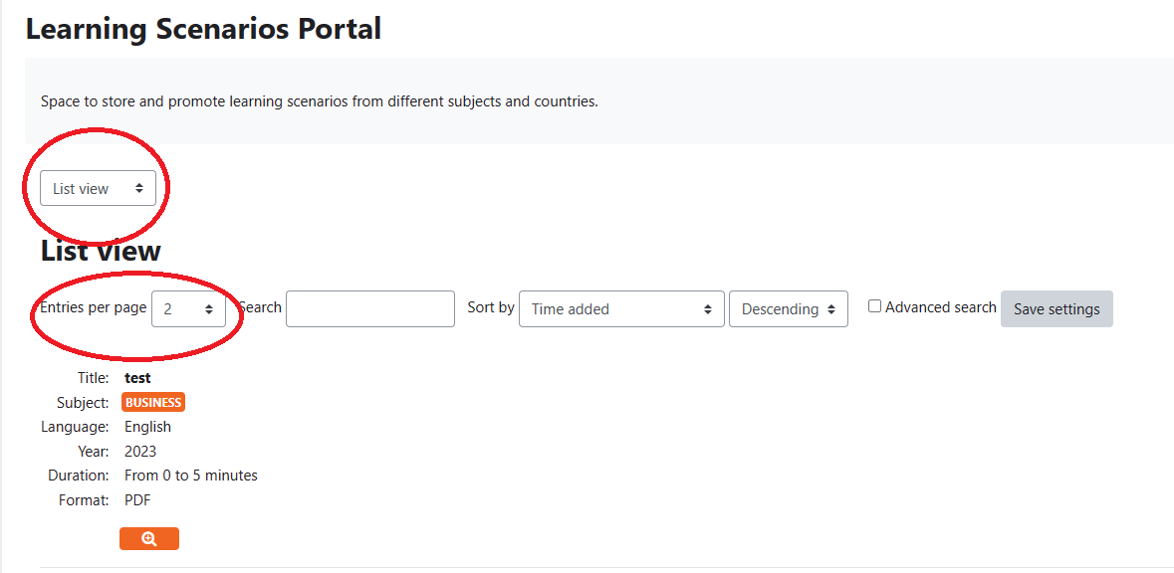
Figure 3: Check List or Single View and Select Entries per page
4. Searching and Sorting Scenarios:

- Search: Use this search bar to find specific learning scenarios quickly.
- Sort by: Sort learning scenarios based on various criteria:
  - Duration: Length of the learning scenario.
  - Format: Type of resource (e.g., PDF, Video).
  - Language: Language in which the scenario is presented.
  - Learning resource file: Direct file resources.
  - Learning resource URL: Web links to resources.
  - Subject: Academic subject or topic.
  - Title: Name of the learning scenario.
  - Year: Publication or creation year.
- Advanced Search: Use the advanced search option for a more refined search.

The following figure shows the fields mentioned before:
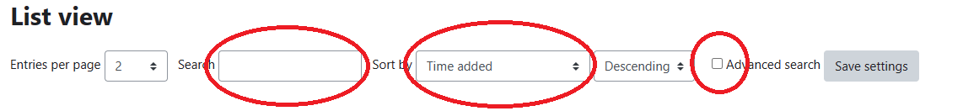
Figure 4: Search, Sort by and Advances Search fields
5. Understanding Learning Scenario Entries:

Each learning scenario entry provides detailed information:

- Title: Name or title of the scenario.
- Subject: Academic subject or field of the scenario.
- Language: Language of the content.
- Year: Year of publication or creation.
- Duration: Estimated time to complete the scenario.
- Format: Type of resource, such as PDF or Video.

When a user presses the "Magnifying Glass" icon, users can see the Learning Scenario Information, and they can see or download it.

The following figure shows the fields mentioned before:

6. Single Learning Scenario:

Here is a single Learning Scenario Example:

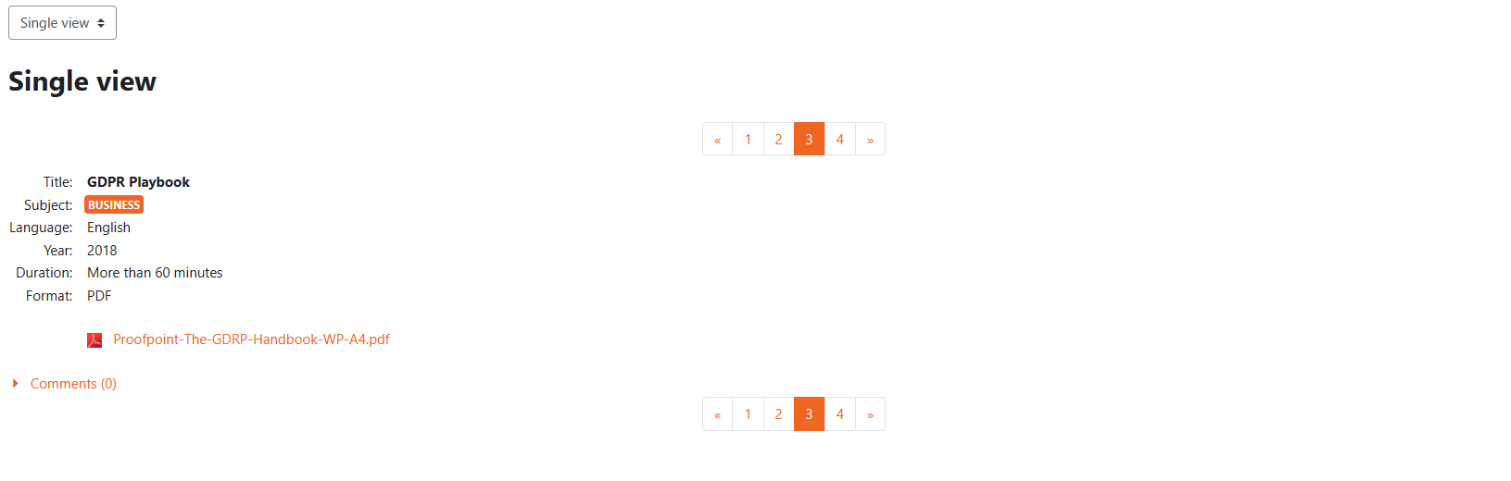
Figure 5: Single Learning Scenario Example

Once you've accessed a single learning scenario, you'll find the following details:

- Title: This is the name of the learning scenario. For this guide, the title is "GDPR Playbook".
- Subject: The academic or thematic topic the scenario covers. In this case, it's "BUSINESS".
- Language: The language in which the scenario is presented. The "GDPR Playbook" is in English.
- Year: The year of publication or creation. The "GDPR Playbook" was created in 2018.
- Duration: An estimate of how long it will take to complete the scenario. The "GDPR Playbook" is expected to take "More than 60 minutes".
- Format: The type of resource available. The "GDPR Playbook" is available in PDF format.
- Resource: A direct link or file associated with the scenario. For "GDPR Playbook", there's a PDF titled Proofpoint-The-GDRP-Handbook-WP-A4.pdf (Note: Ensure you click the link on the portal to access the resource).

With each learning Scenario you have two options:

Engaging with the Learning Scenario:
- Download or view the resource directly from the portal.
- Review the content and determine how it fits your teaching or learning objectives.
- Implement the scenario in your classroom or training session as needed.

Providing Feedback:

After reviewing or using the scenario, you can provide feedback or comments. Engage with the community by sharing your insights or asking questions.

The Next Section shows how you can upload your Learning Scenario.

Adding New Learning Scenarios

Why add a Learning Scenario in the repository?

By uploading your learning scenarios, you're not just sharing a lesson plan but contributing to a global repository of educational wisdom. Here's why you should consider sharing your best practices through learning scenarios:

- Elevate the Teaching Community: You uplift the entire teaching community every time you share. Your unique insights and methods can inspire another educator halfway across the world.
- Legacy of Learning: Your learning scenarios are a testament to your dedication and expertise. They are a lasting legacy, benefiting countless students and educators for years.
- Feedback and Growth: Sharing opens the door to feedback. Constructive insights from peers can help refine your methods, leading to personal and professional growth.
- Promote Lifelong Learning: By sharing, you emphasize the importance of continuous learning, not just for students but for educators as well. It's a powerful statement about the ever-evolving nature of knowledge.
- Broaden Horizons: Your scenarios might introduce new perspectives, cultures, or methodologies others haven't encountered. This diversity enriches the educational tapestry.
- Strengthen the Network: The more educators contribute, the more robust and comprehensive the Learning Scenarios Portal becomes. It transforms into a one-stop hub for quality education resources.
- Recognition and Opportunities: Sharing your work can lead to recognition within the educational community. It can open doors to collaborations, workshops, and other professional opportunities.

Every learning scenario you upload is a beacon of knowledge, guiding and inspiring others on their educational journey. So, please take a moment, reflect on your best practices, and consider sharing them. In doing so, you're not just teaching; you're shaping the future of education.

Learning Scenario Template
The Learning Scenario Template is a comprehensive tool designed for educators to outline and share their unique teaching scenarios. This structured format ensures that each scenario is detailed, making it easily understandable and replicable by other educators. Here's an overview of each field:

- Title: The name or headline of the scenario, providing a quick glimpse of the topic or theme.
- Subject: The academic or thematic domain the scenario addresses.
- Grade Level: The age or grade range suitability of the scenario.
- Duration: An estimate of the time the scenario will take.
- Objective(s): The learning outcomes or goals aimed to be achieved.
- Pedagogical Methods: The teaching strategies or approaches employed in the scenario. This could range from traditional lecture-based methods to more interactive techniques like problem-based learning.
- Structure: A clear outline of the sequence or flow of the scenario, detailing how activities and content are organized and presented.
- Materials/Resources: Essential tools, materials, or technologies required for the scenario.
- Pre-requisites: Any foundational knowledge or skills students should already possess.
- Activities & Procedures: A detailed guide on executing the scenario, from start to finish.
- Assessment/Evaluation: Tools or methods to gauge student understanding or performance.
- Extensions/Modifications: Ideas for expanding or tailoring the scenario to different learning needs.
- Additional Notes: Space for other pertinent information, insights, or tips.
- Attachments/Links: A section to provide supplementary resources or materials that complement the scenario.

By utilizing this template, educators can ensure a holistic representation of their learning scenario, facilitating peers to understand, adapt, and employ it seamlessly in diverse educational settings.

Here is the Learning Scenario template:

Title | Name or title of the learning scenario.
Subject | Academic subject or thematic area the scenario covers.
Grade Level | Appropriate grade or age level for the scenario.
Duration | Estimated time required to complete the scenario (e.g., 45 minutes, 2 hours).
Objective(s) | Clear learning outcomes or goals for the scenario.
Pedagogical Methods | Teaching strategies or approaches used in the scenario (e.g., Inquiry-based learning, Flipped Classroom).
Structure | Outline of the sequence or flow of activities and content in the scenario.
Materials/Resources | List of materials, tools, or technologies required.
Pre-requisites | Any prior knowledge or skills students should have.
Activities & Procedures | Step-by-step guide on how to conduct the scenario, including any activities.
Assessment/Evaluation | Methods or tools to evaluate students' understanding or performance.
Extensions/Modifications | Suggestions for extending the scenario or modifying it for different learners.
Additional Notes | Any other relevant information or tips for implementing the scenario.
Attachments/Links | Attach or link to any supplementary resources or materials.

